Call for Registration for the 2017 CAPANA Conference
Dongbei University of Financial and Economics
Dalian, China
July 20-21, 2017

We cordially invite you to join us in the beautiful coastal city of Dalian, China for the 2017 CANAPA Research Conference and also celebrate the 10th anniversary of this annual conference.

Please refer to the following information for details of registration and hotel reservation. Please complete and email the registration form at the end of this document to Dr. Yunyun Jin at reserve_ifcc@163.com before June 15, 2017.

For questions on PayPal payment, please contact our Treasurer, Dr. Shifei Chung at chung@rowan.edu or (856) 256-4500 Ext. 3032.

For questions on conference logistics or hotel reservation, please contact Dr. Yunyun Jin at reserve_ifcc@163.com or (86)135-0073-9770.

Registration deadline is June 15, 2017.

- Registration Fee

The registration fee includes conference materials, the reception, coffee breaks, and meals. A receipt will be issued to you at the conference. All participants are responsible for their own travel and accommodation costs.

Please pay the required registration fee (as indicated in the registration form) by PayPal using the following link:
https://www.paypal.com/cgi-bin/webscr?cmd=_s-xclick&hosted_button_id=59Y9AUWW9MAFJ

You can also reach this link by visiting the registration page at CAPANA website:
http://info.capana.net/2017-registration/

Your registration is not complete until you pay the registration fee by PayPal and email your registration form (except for Mainland Chinese participants).

For Mainland Chinese participants, you can either use the above PayPal link to pay $100 USD registration fee, or you can pay ￥700 RMB registration fee in cash to one of our CAPANA officers when you register on site at the time of the conference. Even if you plan to pay RMB in cash on site, you still need to complete and email the registration form before the registration deadline.

- Hotel Information

Dalian International Finance Conference Center (大连国际金融会议中心IFCC)
Address: No.68, Binhai Road, Xigang District, Dalian, 116000, China
(In Chinese: 大连国际金融会议中心，大连市西岗区滨海西路68号)

IFCC is located by the south coast of Dalian with beautiful ocean and mountain views.

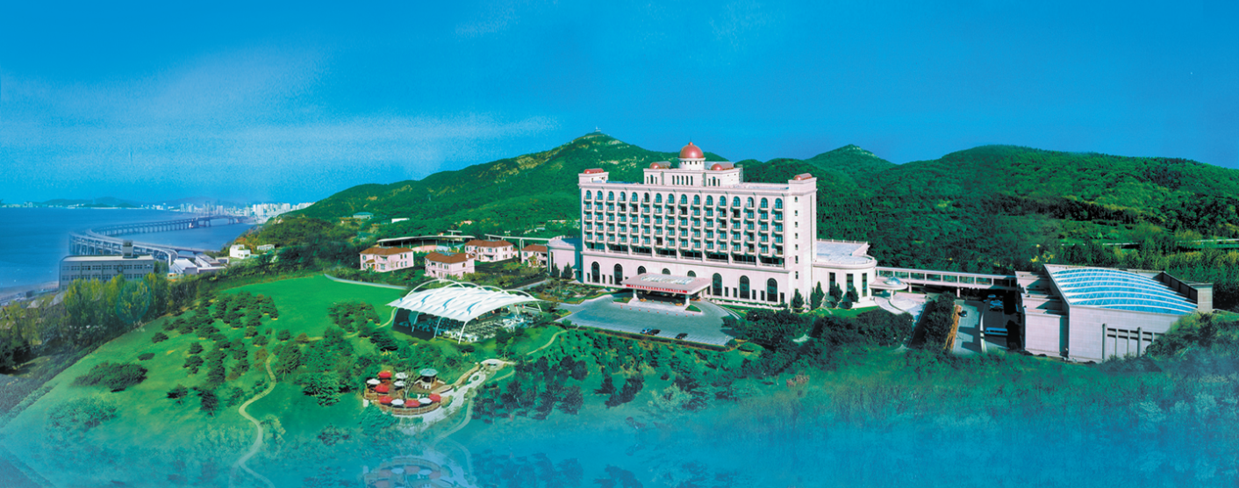

While we provide two hotel options, we strongly recommend IFCC which is where the conference will be held. Because of the popular location of the hotel and the peak season of summer, the hotel requires a one-night deposit for reservation. If you are unable to attend the conference after reservation, this deposit is not refundable. Please see next page for detailed instruction on how to reserve and pay the deposit.

Reservations (including deposit) received by 6/15/2017 will be guaranteed based on the following special group rate for conference participants:

Special group rate | Type of room | One/double breakfast
850 RMB (about $125*) | Deluxe King Room  豪华大床房 | One breakfast
Executive Twin Room
行政双床房
950 RMB (about $139*) | Deluxe King Room  豪华大床房 | Double breakfast
Executive Twin Room
行政双床房
Extra breakfast is 128 RMB each person. The number of Deluxe King Rooms is limited.

*The hotel settles room charges in RMB. So your final payment in USD at checkout (using either Visa or MasterCard) will be based on the exchange rate on that day and can be slightly different than the rate above.

How to reserve:

Your room is guaranteed if you email the registration form and pay the one-night deposit ($125 for single breakfast and $139 for double breakfast) by 6/15/2017.

For overseas participants, please use the following link to pay one-night deposit (you can combine your registration fee and your hotel deposit in one PayPal payment):
https://www.paypal.com/cgi-bin/webscr?cmd=_s-xclick&hosted_button_id=59Y9AUWW9MAFJ

For mainland participants, please make a RMB remittance of one-night deposit to account number 2120 1501 3100 5999 9999（账户名称：中国人民银行大连培训中心；开户行：建设银行大连分行付家庄支行）, indicating “CAPANA Conference” and your name.

For more hotel information, please contact Ms. Fang Sun of IFCC at dlbkhotel@126.com or (86) 0411-82408752.

Alternative Hotel

Dalian Sea Horizon Hotel (大连海天白云大酒店, SHH)
Address: No.81 Binhai Road, Xigang District, Dalian, China
(In Chinese: 大连海天白云大酒店，大连市西岗区滨海西路81号)

This hotel is about 10 minute walk away from our conference hotel.

Special group rate | Type of room | One/Double breakfast
580 RMB (about $84*) | Standard King Room  标准大床房 | One breakfast
Standard Twin Room
标准双床房
630 RMB (about $92*) | Standard King Room  标准大床房 | Double breakfast
Standard Twin Room
标准双床房
Extra breakfast is 68 RMB each person. The number of standard king room is very limited.
* No deposit is required for SHH reservation. We will book the rooms for you. You can pay with VISA, MasterCard, or UnionPay when you check in. The hotel settles room charges in RMB. So your final payment in USD at checkout will be based on the exchange rate on that day and can be slightly different than the rate above. For more hotel information, please contact Ms. Xueqing Jiang of SHH at jiangxueqing0411@163.com or (86)130-5059-1568.

2017 CAPANA Conference Registration Form
Dongbei University of Financial and Economics
Dalian, China
July 20-21, 2017

Please complete and email the registration form to Dr. Yunyun Jin at reserve_ifcc@163.com by June 15, 2017.

- General Information
Last Name |  |  |  |  | First Name
Nickname on Name Tag |  |  |  |  | Affiliation
Telephone |  |  |  |  | Email
Indicate YES if you plan to attend any of the following events (they are included in the registration fee) |  |  | Evening reception on July 19
 |  |  | Lunch on July 20
 |  |  | Dinner on July 20
 |  |  | Lunch after the conference on July 21
- Registration Fee
Participant type |  |  |  |  | Registration fee | Please check one
1. CAPANA member (including paper presenter) |  |  |  |  | USD 250
2. Non-CAPANA member (including paper presenter)* |  |  |  |  | USD 370
Please indicate whether you want to become a CAPANA member and have your contact information added to our database. Once you become member, you will pay member rate for registration fees for future conferences. Yes [ ] No [ ]
3. Invited discussant |  |  |  |  | USD 0
4. CAPANA officer |  |  |  |  | USD 0
5. Mainland Chinese participants# |  |  |  |  | USD 100 or  RMB 700
- Hotel Reservation
Please indicate your hotel preference: IFCC [ ] SHH [ ]
Last Name |  |  |  | First Name |  | Gender
Type of Room |  |  |  |  | One or Double Breakfast
Check-in Date |  |  |  |  | Check-out Date
- PayPal Information (for those who made PayPal payments)
Name on your PayPal account if different than registrant ______________________

Any additional information:

If your hotel preference is IFCC, your reservation is not complete until you pay one-night deposit and email the registration form to reserve_ifcc@163.com by 6/15/2017.

If your hotel preference is SHH, you only need to complete the registration form and email to reserve_ifcc@163.com by 6/15/2017.

