Call for Registration for the 2019 CAPANA Conference
Harbin Institute of Technology
Haerbin, China
June13-15, 2019

We cordially invite you to join us in the beautiful historical and cultural city of Haerbin, China for the 2019 CANAPA Research Conference. Please refer to the following information for details of registration and hotel reservation. Please complete and email the registration form at the end of this document to Dr. Xin Ding at CapanaHITkj2019@163.com before April 30, 2019.

We would like to make you aware of a special situation we face this year. Due to the Chinese government policy change last year, all domestic conferences cannot have attendees exceeding two nationality including Chinese. To comply with this policy, we have to restrict the conference attendees to those who hold either an US or Chinese passport. We are sorry for any inconvenience this will have caused and hope you understand it.

For questions on PayPal payment, please contact the Treasurer, Dr. Shifei Chung at chung@rowan.edu or 856-322-2505.

Registration deadline is April 30, 2019. Please note that reservation at the conference hotel is guaranteed if made by April 30, 2019, and is subject to availability afterwards.

- Registration Fee

Except for invited discussants and conference organizers, all conference participants (including presenting authors) are required to pay a registration fee of US$250 for CAPANA member, US$370 for non-members, or RMB700 for participants from China. The registration fee includes conference materials, receptions, tea breaks, and meals. Receipts will be emailed to participants by the CAPANA. All participants are responsible for their own travel and accommodation costs. Registration fee is waived for young scholars from China (with less than six years of working experience) and doctoral students.

Please pay the required registration fee (as indicated in the registration form) by PayPal using the following link:
https://www.paypal.com/cgi-bin/webscr?cmd=_s-xclick&hosted_button_id=59Y9AUWW9MAFJ

You can also reach this link by visiting the registration page at CAPANA website:
http://info.capana.net/2019-registration/

Your registration is not complete until you pay the registration fee by PayPal and email your registration form.
Verify the registration fee has been paid on arrival with the receipt. Then the organizer, Harbin Institute of Technology, will check you in.
Special note: If you choose the on-site payment method, only cash payment is available at the conference site. The receipt of the payment will be sent by email after the meeting.

- Hotel Information

Harbin Sinoway Hotel (HSH) 哈尔滨华融饭店
Address: No. 2 Yiyuan Street, Nan Gang, Haerbin, Heilongjiang, China
(中国黑龙江省哈尔滨市南岗区颐园街2号)

Sinoway hotel is located in Harbin, a famous city in north China. There are sunny "sun island", there are also wonderful wonders of ice and snow. Sinoway the center of the hotel is located in the snow and ice city, abuts tyurin company, it loose ray malls such as the important shopping plaza in Harbin, adjacent to the Harbin railway station, from Harbin taiping international airport only 30 minutes by car, traffic is convenient, the unlimited business opportunities, the geographical superiority, is the best choice for guests from all over the world business activity.
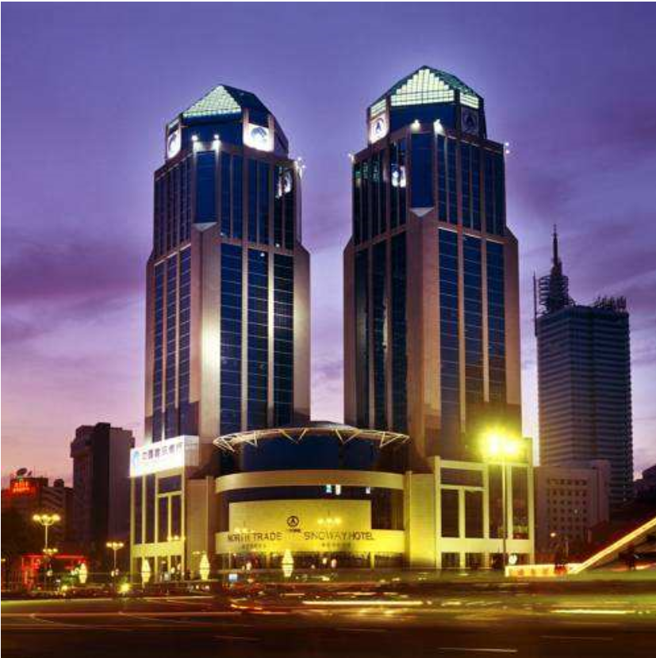

Reservations received by April 30, 2019 will be guaranteed a room. Reservations received after April 30, 2019 will be subject to general availability.
As long as there are rooms available, you will enjoy the following special group rate for conference participants:
Special group rate | Type of room | One/double breakfast
450RMB (about $67*) | Business Standard Single Room  商旅标间大床房 | One breakfast
540 RMB (about $81*) |  | Two breakfast
450 RMB (about $67*) | Business Standard double Room  商旅标间双床房 | One breakfast
540 RMB (about $81*) |  | Two breakfast
The above prices include Chinese and Western buffet breakfast.
*The hotel settles room charges in RMB. So your final payment in USD at checkout (using either Visa or MasterCard) will be based on the exchange rate on that day and can be slightly different than the rate above.

Traffic Guidance
HarbinTaiping international airport | Take a taxi to Sinoway hotel directly (about 120-140 RMB)
 | Take the airport bus line 1 to Harbin railway station (20 RMB /person), walk 5-10 minutes to the museum of the Hongjun street to the left of the Youzheng street 20 meters or take a taxi to Sinoway hotel (the fee is 9 RMB)
Harbin west railway station | Take a taxi to Sinoway hotel directly (the fee is about 30-35 RMB)
 | Take metro line 3 to the Yidaeryuan station, then transfer to line 1 at the Yidaeryuan station and get off at the museum station (exit 3b)，walk about 540 meters to Sinoway hotel

How to reserve:

If you are reserving HSH by April 30, 2019:

Your room is guaranteed if you email the registration form and reserve the hotel room by April 30, 2019.（CapanaHITkj2019@163.com）
For more hotel information, please contact HSH
atTel：86-451-86291111 or http：www.sinowayhotel.com

Alternative Hotel

James Joyce Coffetel (JJC,喆啡酒店哈尔滨工业大学店)
Address: NO.55 Yikuang Street, Nangang District, Haerbin
(In Chinese: 哈尔滨南岗区一匡街55号)

Special group rate | Type of room | One/Double breakfast
260 RMB(about $39*) | Single Room | One breakfast
260 RMB(about $39*) | Double Room | Two breakfast

The hotel settles room charges in RMB. So your final payment in USD at checkout (using either Visa or MasterCard) will be based on the exchange rate on that day and can be slightly different than the rate above.

Traffic Guidance
HarbinTaiping international airport | Take a taxi to James Joyce Coffetel directly (about 110-130 yuan)
 | Take the airport bus line 2 to Hexinglu station (20 RMB /person), walk 1.6KM or take a taxi to James Joyce Coffetel (the fee is 9 RMB)
Harbin west railway station | Take a taxi to James Joyce Coffetel directly (the fee is about 20-25 RMB)
 | Take metro line 3 to the Yidaeryuan station, then transfer to line 1 at the Yidaeryuan station and get off at Xidaqiao station，walk about 940 meters to James Joyce Coffetel.

2019 CAPANA Conference Registration Form
Harbin Institute of Technology
Haerbin, China
June13-15, 2019

Please complete and email the registration form to Dr. XinDing at CapanaHITkj2019@163.com by April 30, 2019. (Please note that the conference hotel room is guaranteed if reservation is made and deposit paid by April 30, 2019.)

- General Information
Last Name |  |  |  |  | First Name
Nationality（based on passport） |  |  |  |  | Affiliation
Telephone |  |  |  |  | Email
Indicate YES if you plan to attend any of the following events (they are included in the registration fee) |  |  | Evening reception on June13
 |  |  | Lunch on June 14
 |  |  | Dinner on June 14
 |  |  | Lunch after the conference on June 15
- Registration Fee
Participant type |  |  |  |  | Registration fee | Please check one
1. CAPANA member (including paper presenter) |  |  |  |  | USD 250
2. Non-CAPANA member (including paper presenter)* |  |  |  |  | USD 370
Please indicate whether you want to become a CAPANA member and have your contact information added to our database. Once you become member, you will pay member rate for registration fees for future conferences. Yes [ ] No [ ]
3. Invited discussant |  |  |  |  | USD 0
4. CAPANA officer |  |  |  |  | USD 0
5. Mainland Chinese participants# |  |  |  |  | USD 100 or  RMB 700
- Hotel Reservation
Please indicate your hotel preference: HSH [ ] JJC [ ]
Last Name |  |  |  | First Name |  | Gender
Type of Room |  |  |  |  | One or Double Breakfast
Check-in Date |  |  |  |  | Check-out Date
- PayPal Information (for those who made PayPal payments)
Name on your PayPal account if different than registrant ______________________

If you have other questions about hotel,please contact Dr. Xin Ding at CapanaHITkj2019@163.com or call (86)13936008910(WeChat ID is the same as the phone number).

